### UE20CS301

## Database Management System

## Lab 8 – Functions and Procedures

Name : Renita Kurian

SRN : PES1UG20CS331

Roll No. : 13

1. Function

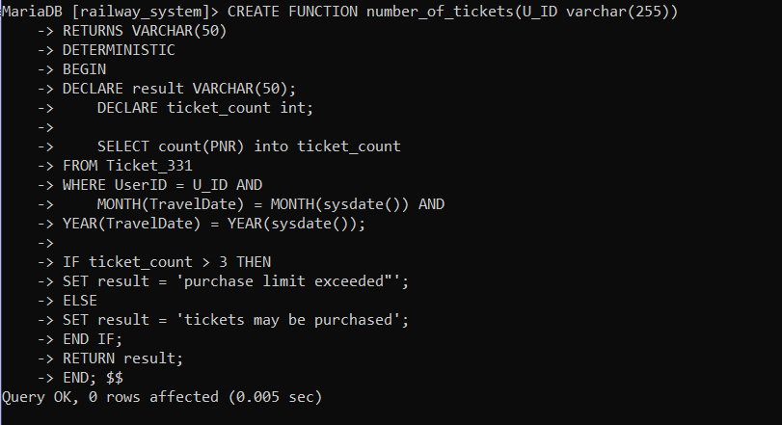

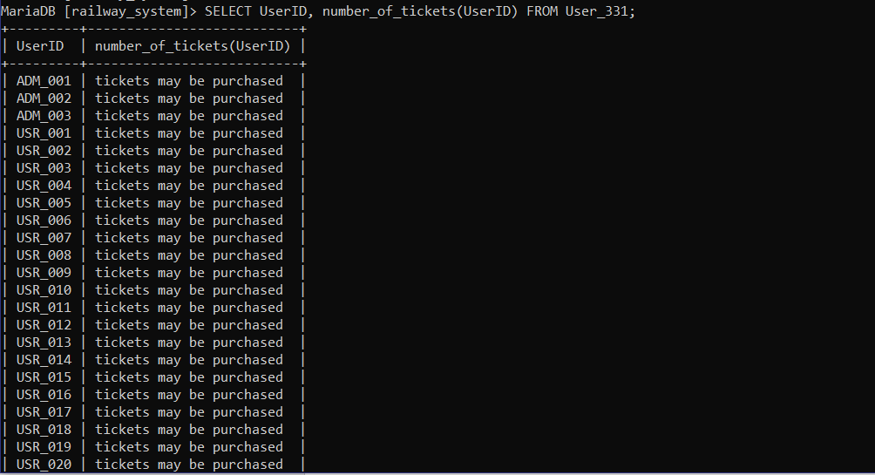

2. Procedure

